Using Git on Windows

We host our project files in a Git repository on my (Sandro’s) private server. In order to get access to them, you need to set up git to work with your computer. This document will provide a rough guide through the necessary steps.

# Install the PuTTY tools

Download the PuTTY installer from this page:

<http://www.chiark.greenend.org.uk/~sgtatham/putty/download.html>

Start the installer and make sure the „Associate .PPK files (PuTTY Private Key) with Pageant and PuTTYgen“ option is checked (see screenshot).

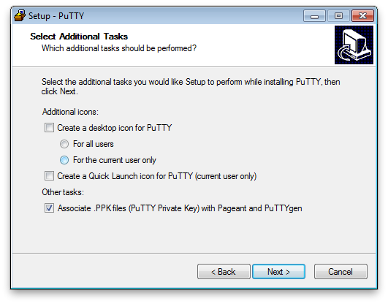

# Create a public/private key pair

Start PuTTYgen to generate a new key pair. Make sure your check the option „SSH-2 RSA“ (see screenshot) and hit the „Generate“ button.

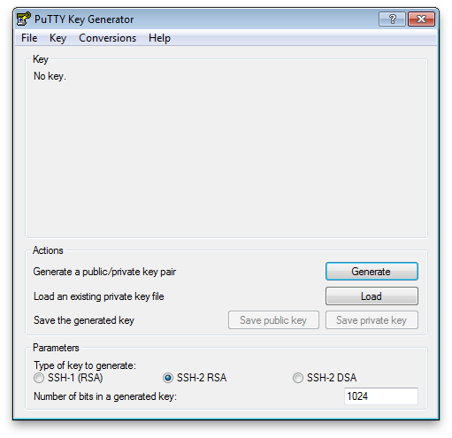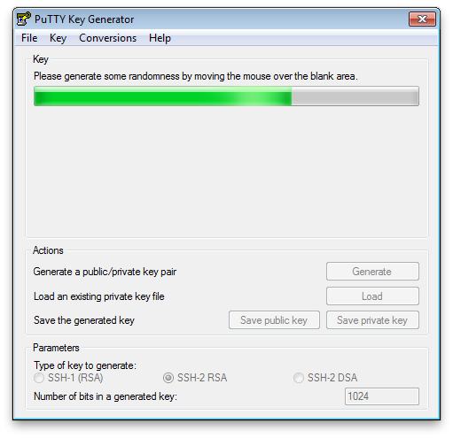

Save both, the public and the private key in a folder on your system. Let’s give them names like id_rsa.pub for the public key and id_rsa.ppk for the private key. Leave the password field empty if you don’t want to enter your password every time you connect to the repository.

Now I need to add your public key to my server in order to grant you access to the repository. So please send the file named id_rsa.pub to my email address.

**Attention:** Never share your private key (the .ppk file) with anyone. This is your very personal access key and must not be accessible to anyone except yourself.

# Add Pageant to your Startup folder

Right-click on „Start | All Programs | Startup“ and select „Explorer“ from the context menu. Right-click in the opening folder and select „New | Shortcut“. Enter the path to pageant.exe and the path to your id_rsa.ppk file into the text field, both put in quotes and separated by a space. (see example):

"C:\Program Files (x86)\PuTTY\pageant.exe" "%USERPROFILE%\SSH\id_rsa.ppk"

This will make Pageant start up every time you log in, providing git with the private key used for authentication against the git host. Double-click the shortcut you just created in order to start Pageant.

# Install Git for Windows

Go to <http://code.google.com/p/msysgit/downloads/list> and download the latest version of MSysGit and fire off the installer.

On the screen where you are asked to choose how to adjust your PATH environment (see screenshot), select „Run Git from the Windows Command Prompt“.

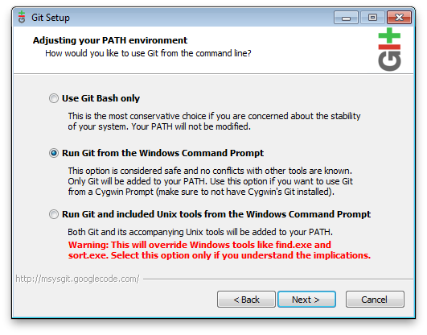

Leave all other options as default and finish the installation.

# Connect to the server

In order to add the server’s key to your registry you need to connect to the server using PuTTY’s plink. Execute plink.exe with the server address as parameter (see example):

C:\Program Files (x86)\PuTTY\plink.exe git@newtonweb.dyndns.org

If you are prompted to trust the server’s identity, type „yes“ and hit enter. The server’s key is now present in your registry and will allow Git to establish an SSH connection to it.

# Make Git use the PuTTY client

By default Git will use the OpenSSH client. But we want it to use the PuTTY client we configured to work with our private key.

On your desktop, right-click on Computer and select „Properties“. Select „Advanced system settings“ from the list on the left and click the „Environment Variables...“ button in the opening window. Under System variables click „New“ and create a new variable named „GIT_SSH“ containing the path to plink.exe (see screenshot):

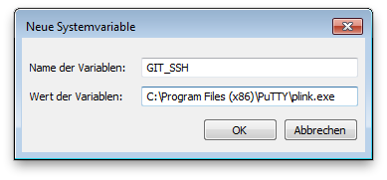

# Set your Home directory

Git will use your home directory to place a file called .gitconfig containing your global Git settings. It will read the path from the environment variable HOME. Make sure this variable is present and points to a directory you have write access to. If this is not the case, change or create the user variable HOME.

On your desktop, right-click on Computer and select „Properties“. Select „Advanced system settings“ from the list on the left and click the „Environment Variables...“ button in the opening window. Under User variables click „New“ and create a new variable named „HOME“ containing the path to your home directory (see screenshot):

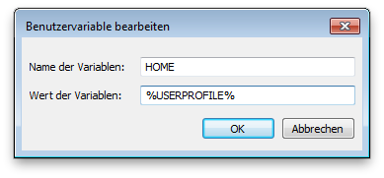

# Verify it works

Once I’ve had the time to add your key to my server, you should be able to clone the project repository.

Open Windows’ command line and switch to a directory, you wish to clone the repository to. Then enter the following command:

git clone git@newtonweb.dyndns.org:PA2011

# Define your name and email address

Before you commit anything to the repository, please configure your name and email address. This makes it easier to keep track on who did what.

Type the following two lines into your command prompt:

git config --global user.name „your name“

git config --global user.email „your email address“

# Using Git

In case you have never worked with Git before, have a look at this tutorial:  
<http://schacon.github.com/git/gittutorial.html>